1: Slide(1-2)

Garbage Collection

Example: You are sleeping at Sunday early morning. A friend ask money and u said no. But frined ask for suiside then you ask for money from some other frnds . But frnds forgot to return money like programmer forgt to delete memory.

2:Slide(3-5)

Example: After taking tea, we want to search dustabine to throw paper cup.

3:Slide(6-7)

4:Slide(8-9)

Example:

ISLAND- land surrounded by

Ship Titanic sinking – persons provide support to others by holding hands but all sinking

5:slide(10-12)

Example: Assitance form house work at morning or evening

1st paper I throw, she cleans

2ND paper I throw, she cleans

1RD paper I throw, she cleans

..

.

.

Nst paper I throw, she GIVES LEFT & EARLY

Suppose sudden 10 frnd coming for lunch

Then my mother makes request to assistance but assistance may or may not come…

6:slide(13)

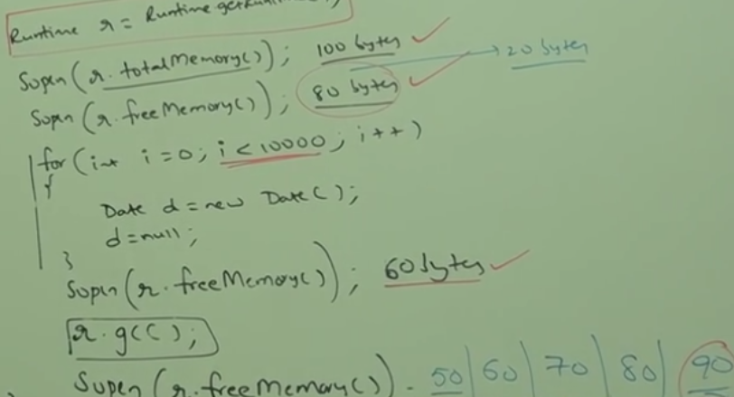

7:slide()

8:

Finalization

Example: Garbage Collector is not a cruel person.

In case 1: why only end of main output is not possible in case of Test object

9:

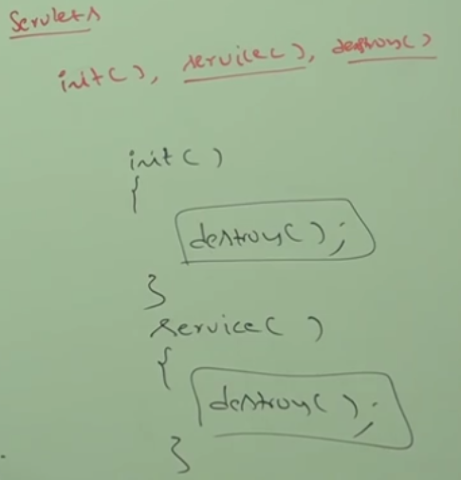

10: Example:

At evening at pizza party in dark on bridge,we want match box. One friends asked traveller for match box, that person don’t have, next person came nd he gives left and right.

At home, parents aked to bring cigratte, for kid have to ingnore that .

Same as programmer(kid) and GC(parent) , if exception oocur in finalize() method.

Example:

If I m observing A CUTE LADY AND papa observed that then he will give me left and right. But if same is doing father the I have to ignore. But I can bring it to mother.

11:

Example, a Analogy:

A vehicle of 23 person 22 died and 1 baby lived after falling vehicle in river on a bridge.

There is no alternative of life so don’t take risk wiith security. It is a good programming practice for ur life.

A frnd waited 20 min for crossing the road while her gf already cross the road.

At end gf said it is very diffult to cross road with frnd then frnd said if a gf gone then we can try to find another gf but if I loss my life then I will not get another.

Same as exception & error.

Last 10 min video

12:

Mark and sweel algo followed by 90- 95 % jvm

Mark the object which has reference and sweep object that does not has.

13: